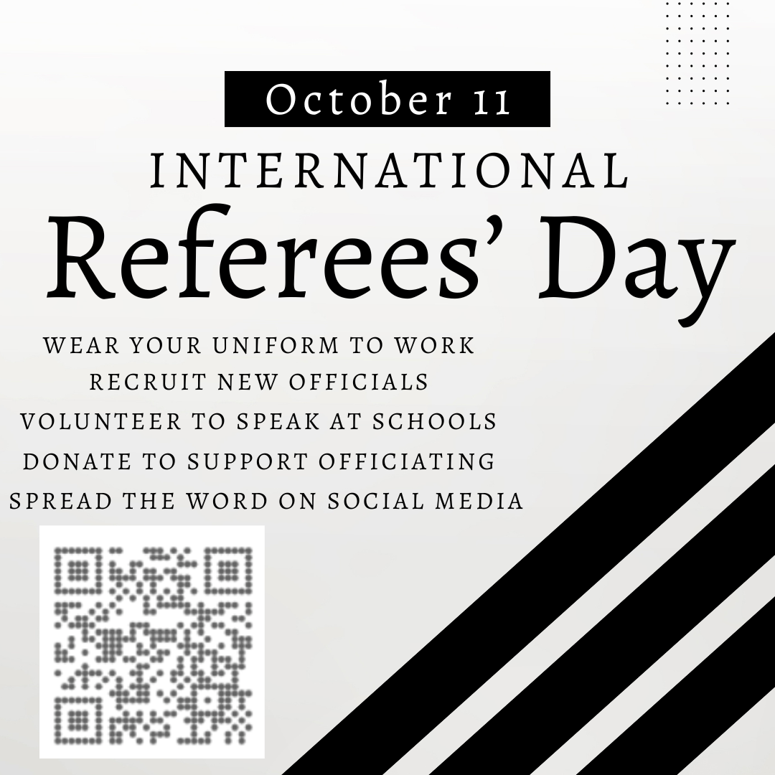

In honor of October 11th, you are invited to participate in virtual football training sessions.

In addition, we challenge all officials to take time on October 11th to spread the word of officiating:

* Recruit at least one new member to this club
* Volunteer to speak at a school
* Wear your uniform to work
* Donate money or time to your local group

Our virtual football officiating training session schedule is below, which culminates with our keynote speaker: 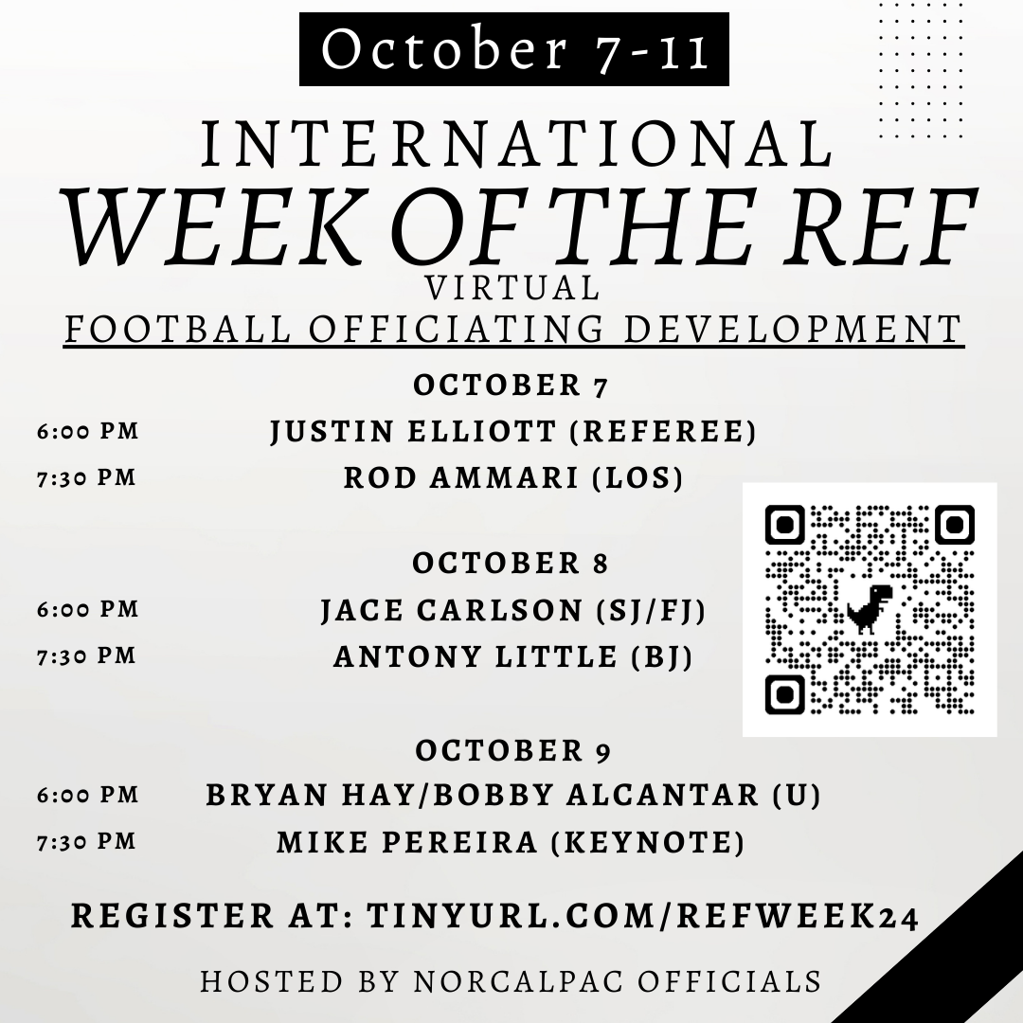

***Football Officiating Analyst, Mike Pereira.***

You will hopefully gain some valuable tips to finish off the second half of the football season. You can register for any and all of the sessions by completing this registration link:

[tinyurl.com/RefWeek24](http://tinyurl.com/RefWeek24)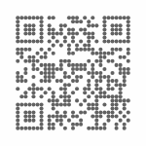

All officials are welcome regardless of position or level at ***no charge***. You are welcome to donate to the hosting group. Contributions are appreciated to help minimize the cost of our annual Ken Rivera Officiating Showcase. Donations also supplement the cost of travel for officials, fund camp attendance, and support officiating throughout the region.

<https://venmo.com/u/norcalpac>

|  |  |  |  |
| --- | --- | --- | --- |
| **WEEK OF THE REF**  **October 7-11** | | | |
| October 7 | | | |
| 6:00 PM PST | Justin Elliott (ACC) | Referee | [R Zoom Link](https://us02web.zoom.us/j/81894084472?pwd=n2tJ9aX9MTrnSeTvUUbacHT3KZHME0.1) |
| 7:30 PM PST | Rod Ammari (B1G) | LOS | [LOS Zoom Link](https://us02web.zoom.us/j/87486369776?pwd=E667YkQbp3BpixTbqG4VwMO3CKH6db.1) |
| October 8 | | | |
| 6:00 PM PST | Jace Carlson (ACC) | SJ/FJ | [Deep Zoom Link](https://us02web.zoom.us/j/81602812009?pwd=px4bQKHExT6bQJPlfUle2eqiVEVGzi.1) |
| 7:30 PM PST | Antony Little (ACC) | BJ | [BJ Zoom Link](https://us02web.zoom.us/j/83419937943?pwd=wdS6IXi4nk8SiX6taSUQbBUYyrWBO0.1) |
| October 9 | | | |
| 6:00 PM PST | Bryan Hay (MWC)  Bobby Alcantar (Big Sky) | Umpire | [U Zoom Link](https://us02web.zoom.us/j/81598737603?pwd=duvETrKSX2lSTKEeTOr5kDhiK9LbCV.1) |
| 7:30 PM PST | Mike Pereira | Keynote | [Keynote Zoom Link](https://us02web.zoom.us/j/86112193466?pwd=vMvXPCkxMT66G6mEP8GtaihTnptXC6.1) |